Elastic Stack Basics - Lab Report

Date: 19/08/2026
Difficulty: Medium
Category: Core SOC Solutions
Platform: TryHackMe

Overview

This lab covers the basics of Elastic Stack (ELK) and how SOC teams can use it to help store, search and visualize data. The lab investigates the different tabs such as discover, dashboard and visualize to search for data and create tables and dashboards to show the data in more visually pleasing ways.

2. What I did

Elastic Stack (ELK) was originally created to store, search and visualize large amounts of data but now many SOC teams use it as part of a SIEM solution. It is a collection of different open-source components that work together to collect data from any source, store and search it and visualize it in real time. It is primarily used by SOC analysts for log analysis and investigations but other components are included such as Elasticsearch which searches within JSON formatted documents, Logstash which processes data and sends it to a destination such as a listening port or Kibana, Beats which are host-based agents which transfer data from the endpoints to Elasticsearch ad finally Kibana which is a web-based data visualization tool.

The Discover tab is where SOC analysts spend most of their time as it shows ingested logs, the search bar, normalized fields and more. Analysts can use this to search for logs, investigate anomalies and apply filters based on search terms and time periods. Kibana requires an index pattern to access the data stored in Elasticsearch. The index pattern tells Kibana which Elasticsearch data we want to explore. Each log source has a different log structure so when logs are ingested into Elasticsearch, they are first normalized into corresponding fields and values by creating a dedicated index pattern for the data source.

In the left panel of the Discover tab, there is a list of the normalized fields in the available logs which shows the top 5 values and the percentage of occurrence. The add filter option under the search bar can be used to apply filters to the fields. You can also filter by time and date as well as viewing the timeline panel which shows the events in a timeline of dates and times.
In the discover tab, I can view the logs from vpn_connections and when I filter by source_ip I can see that the IP 238.163.231.224 is the most used IP address.

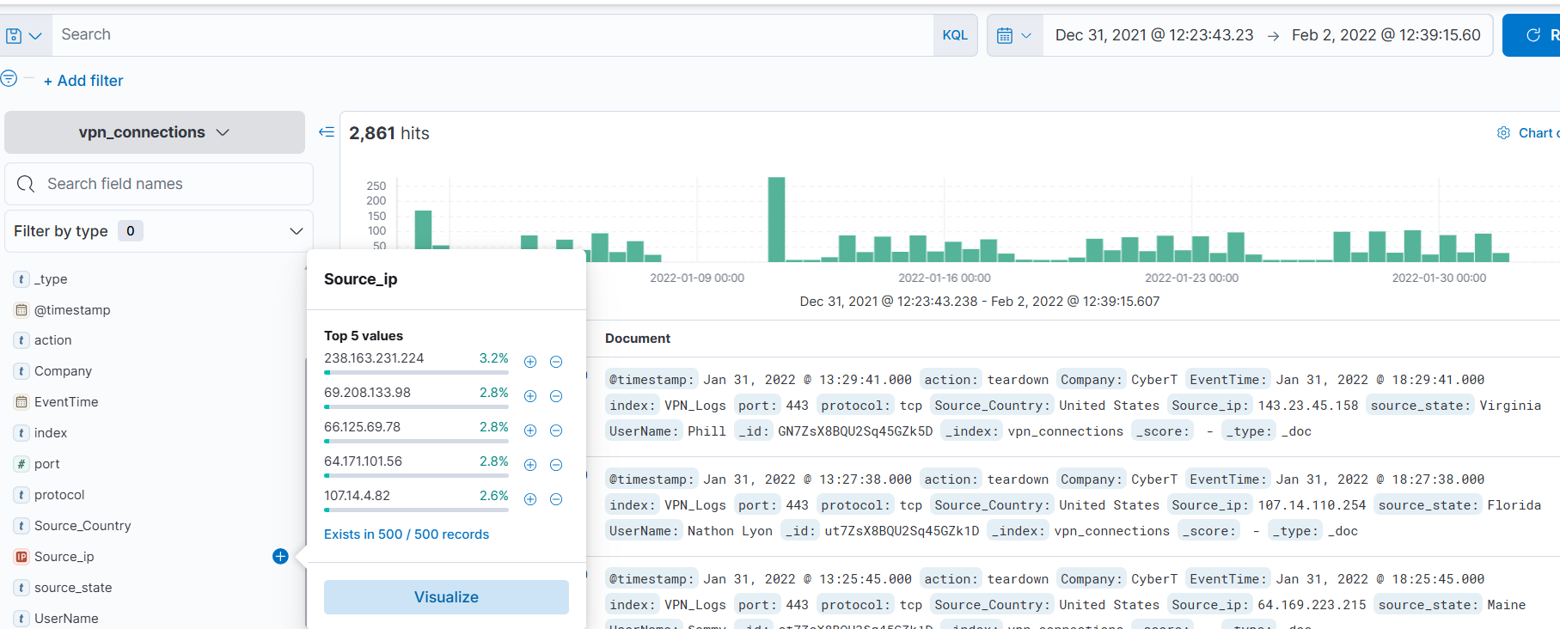

When I filtered for Username: Emanda, I could see what IP address was the most used by them.

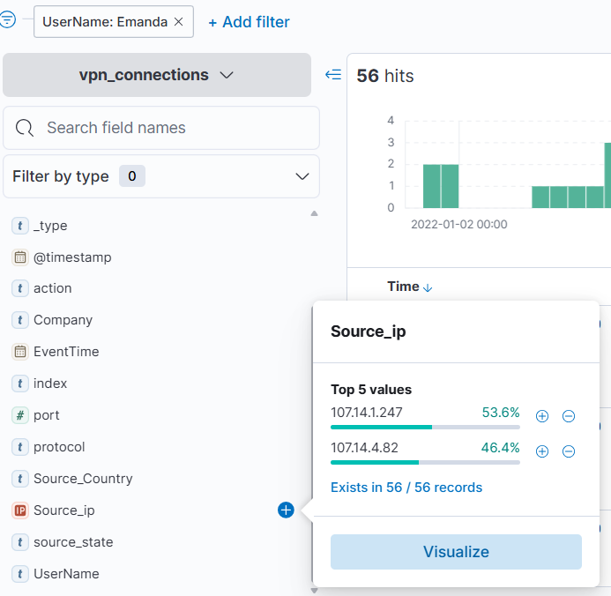

The search bar in the Discover tab can be used to find anything by utilizing KQL (Kibana Query Language). By using KQL, you can search for logs in 2 ways – free text search and field-based search. Free text search allows users to search for logs based on text only. So, if you searched for United states, it would return all the logs that contain that term. You can use * as wildcards which can match parts of the word. It also uses logical operators such as AND/OR/NOT. Field-based search is when you provide the field name and the value you are looking for such as “UserName : Cameron” which would return all usernames which are Cameron.

To show this, I done an example which looks at users named James or Albert from the United States which returned 161 results.
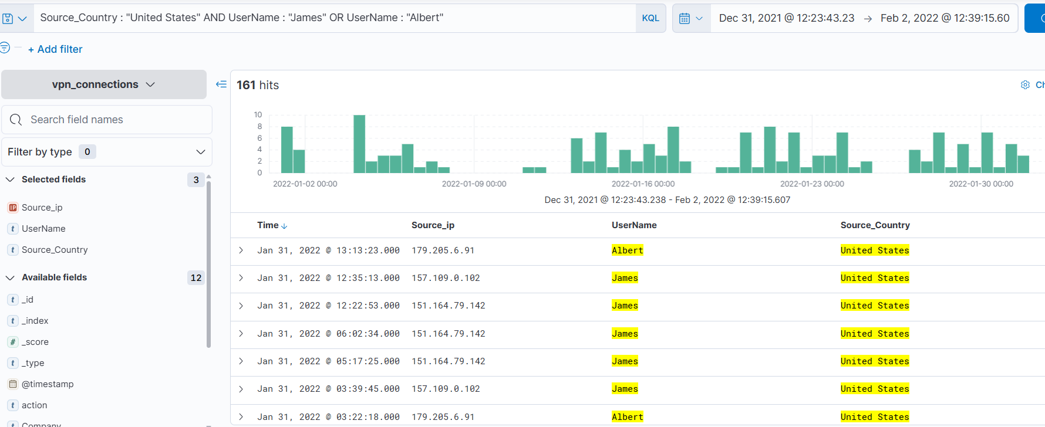

You can use the visualization tab to look at the data in different forms such as tables, pie charts or bar charts. These can be saved to the visualize library once saved for future reference. To show an example of this, I created a table to show the IP address and users involved in failed login attempts.

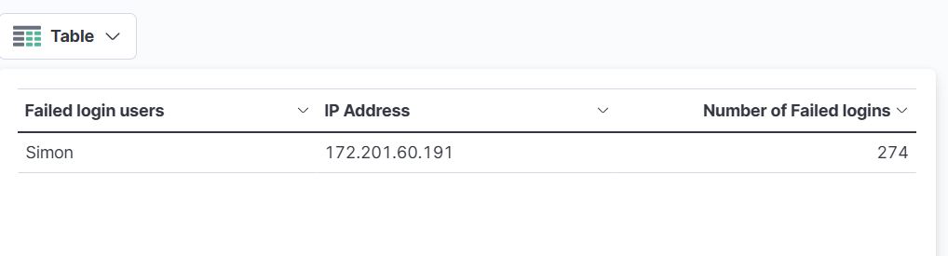

Now in the library, the new table is saved so I can go back and view it at any time.

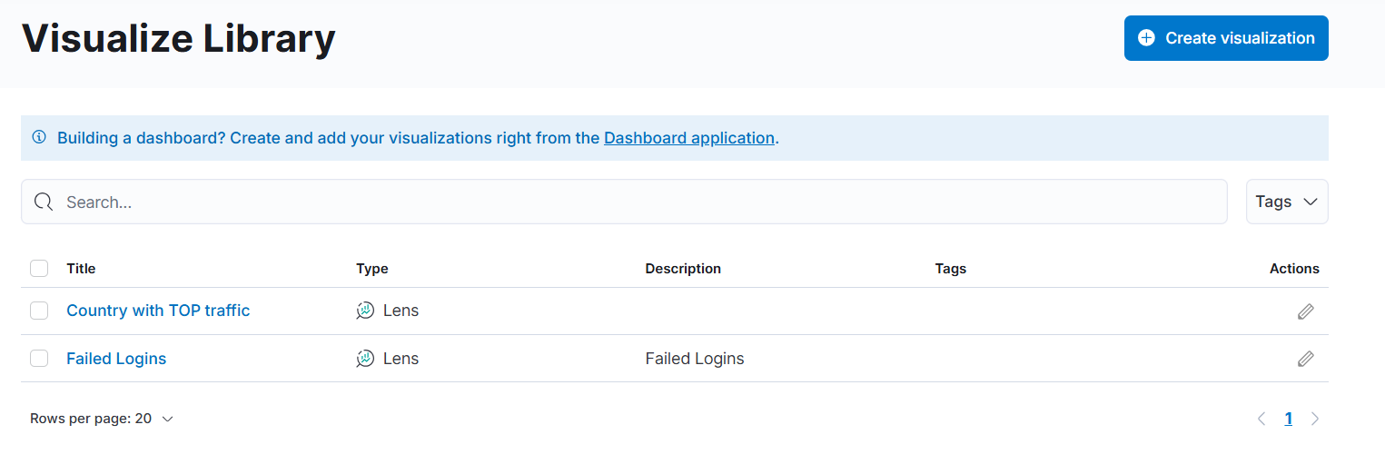

Dashboards can be created for specific needs and combine several saved searches into a custom dashboard for VPN log visibility, for example. To create a dashboard, go to the dashboard tab and click create dashboard > add from library and save dashboard.

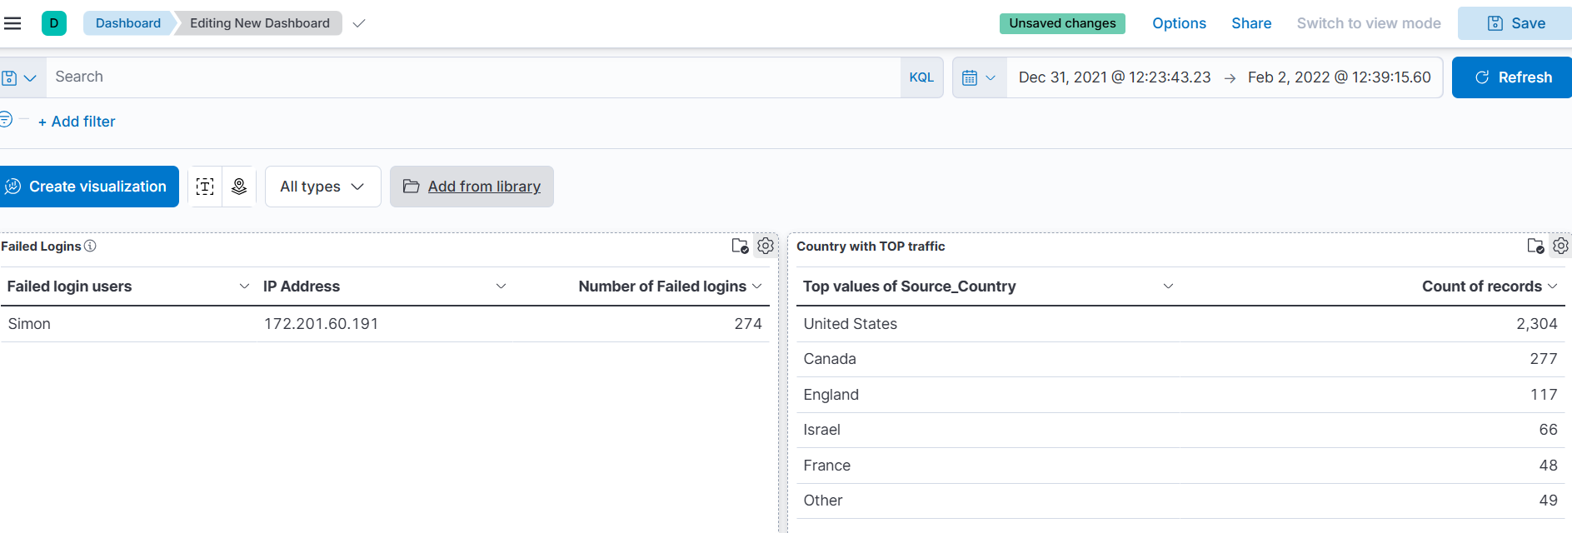

3. What I’ve learned

- What Elastic Stack is
- How it is used by SOC teams
- KQL searches
- Creating visualization and dashboards

